ENFORCING MANDATORY FIELDS USING UI POLICIES AND MIGRATING CHANGES WITH UPDATE SETS

Problem Statements:
In this project we address this issue by implementing a UI policy that makes the priority field mandatory when the state of an incident is set to progress Additionally ,We capture and mitigate this configuration using update sets ,enabling seamless deployment across different ServiceNow Instances.
Objective:
Demonstate exporting and importing the update sets , ensuring configurations can easily transferred between environments.
Skills: UI policy ,UI Actions and update sets.
Task Initiation
Milestone 1: Update set
Activity 1:Create Update set
1.Open service now.
2.Click on All >> search for Update Sets.
3.Select Local Update Sets.
4.Click on new.
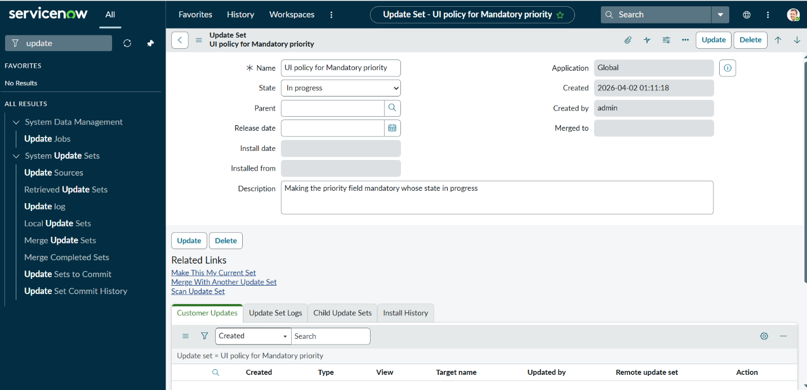
5.Fill the details below and make current.
6.Click Submit.
Milestone 2:UI Policy
Activity 1: Create UI policy
1.Open service now.
2.Click on All >> search for UI Policies.
3.Navigate to System UI >> UI Policies.
4.Click on new.
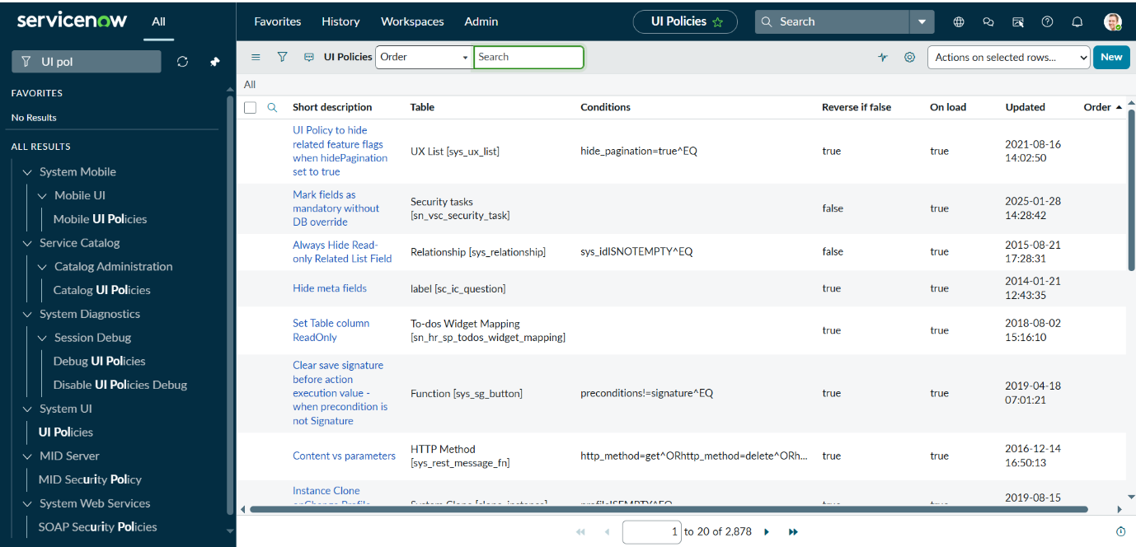
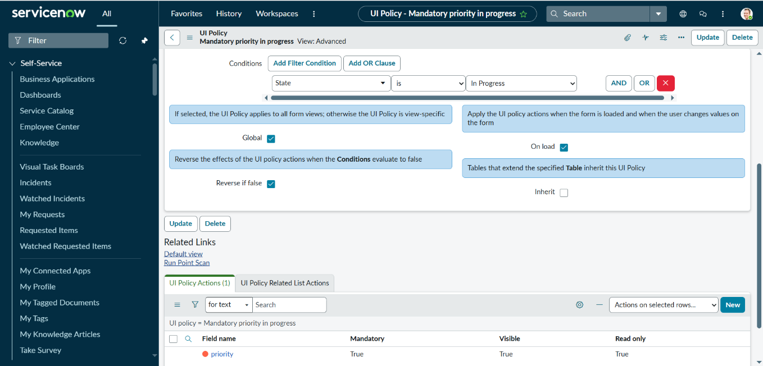
6.Fill the following details and Save
7. Click on submit.
Activity 2: Check Update Set
1.Navigate to the System Update Sets > Local Update Sets.
2.Open the ‘Ui policy for mandatory priority’ Update Set.
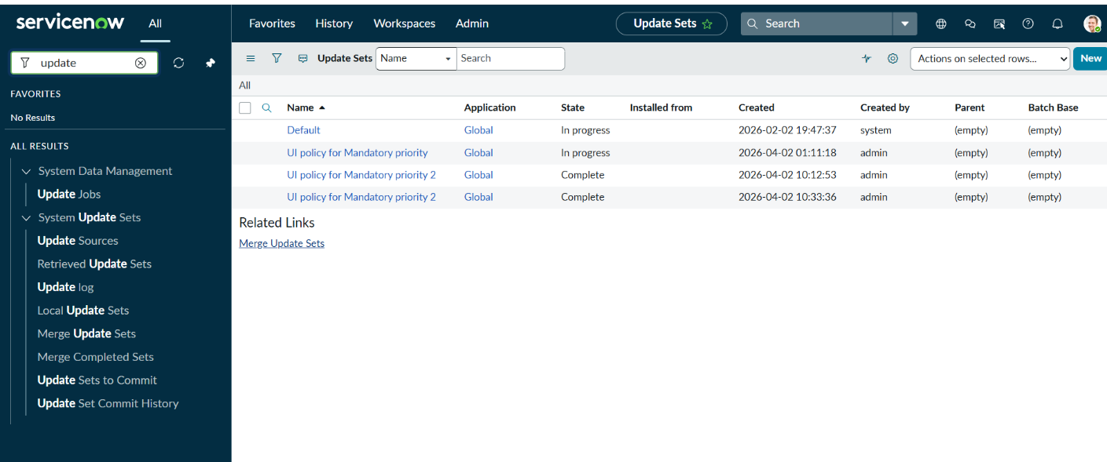
3.Verify that your UI Policy and UI Policy Action are listed.
Activity 3: Export and Import the Update Set
1.Set State to Complete and Click Export to XML on the Update Set record.
2.Download the XML file.
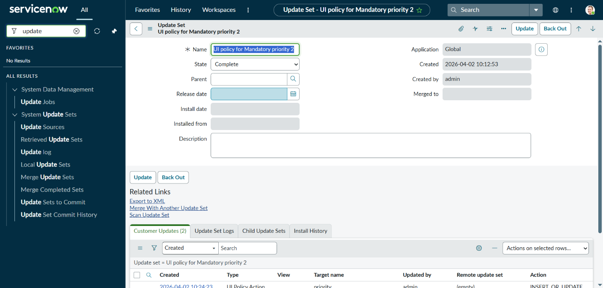
3.Now Open Another Instance to Export Update Set.
4.Go to System Update Sets >> Retrieved Update Sets.
5.Click on the Import update set from XML and Select File and Upload.
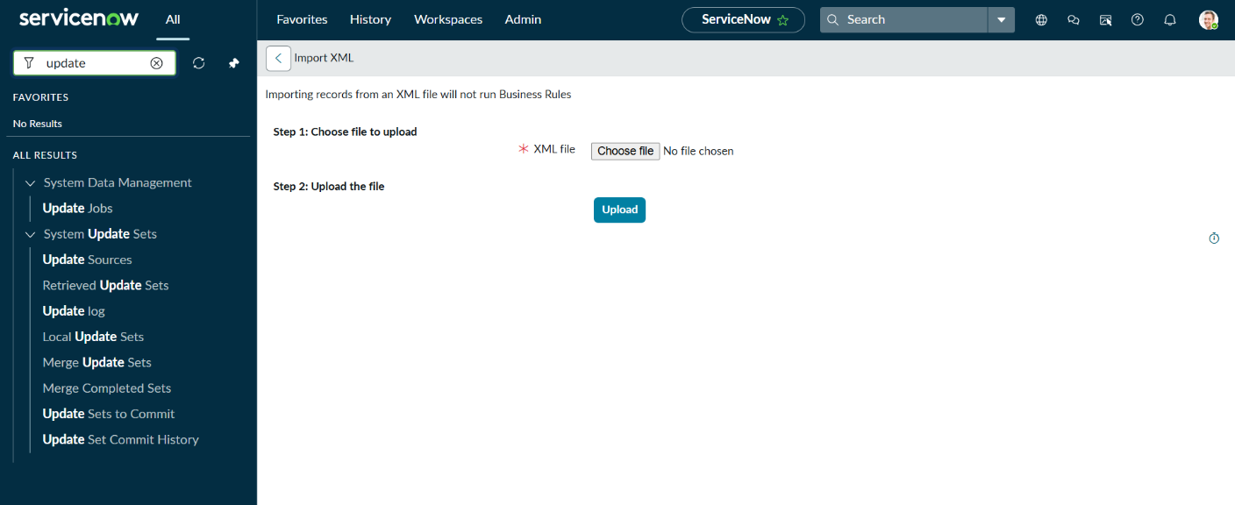
6.Open the update set that you have created in your instance here.
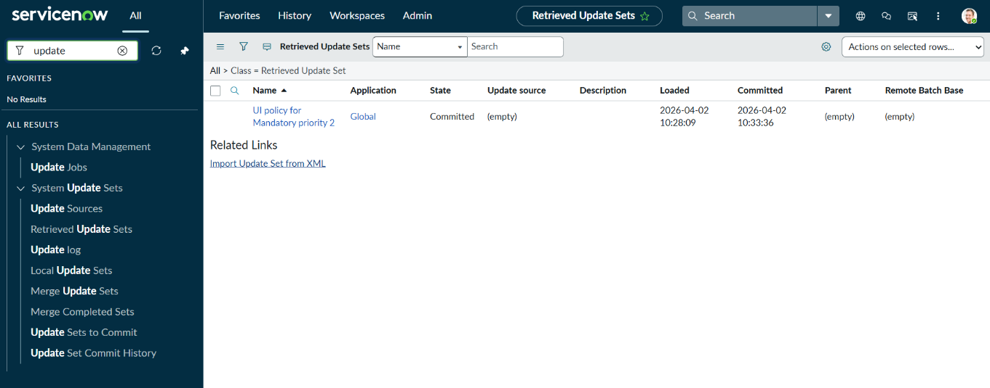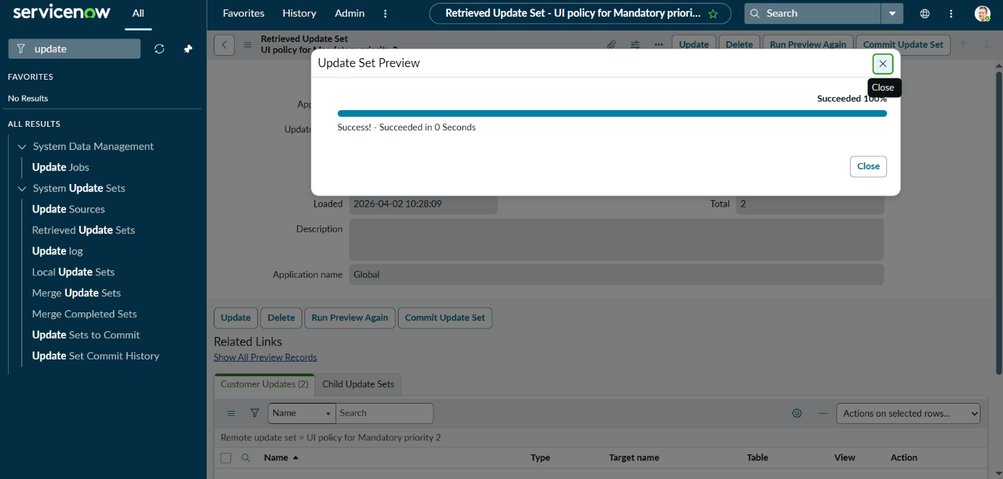
7.Preview the Update Set.
8.Commit the Update Set.
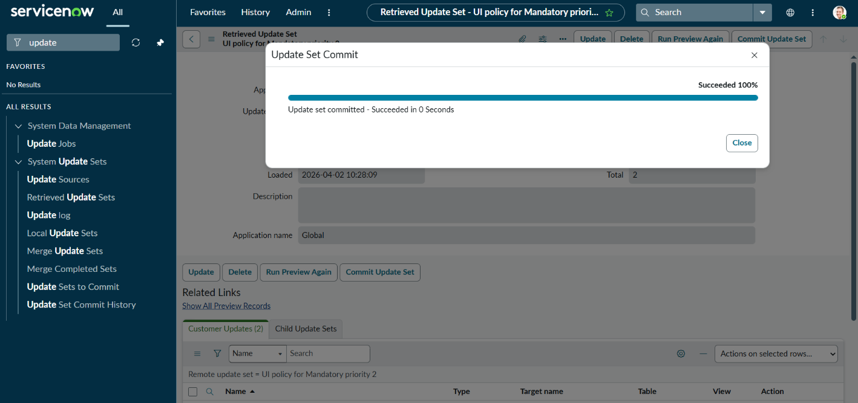
Milestone 3: Result
Activity 1: Testing Incident
1.Go to the incident module.
2.Open an existing incident or create a new one.
3.Change the State is In-progress.
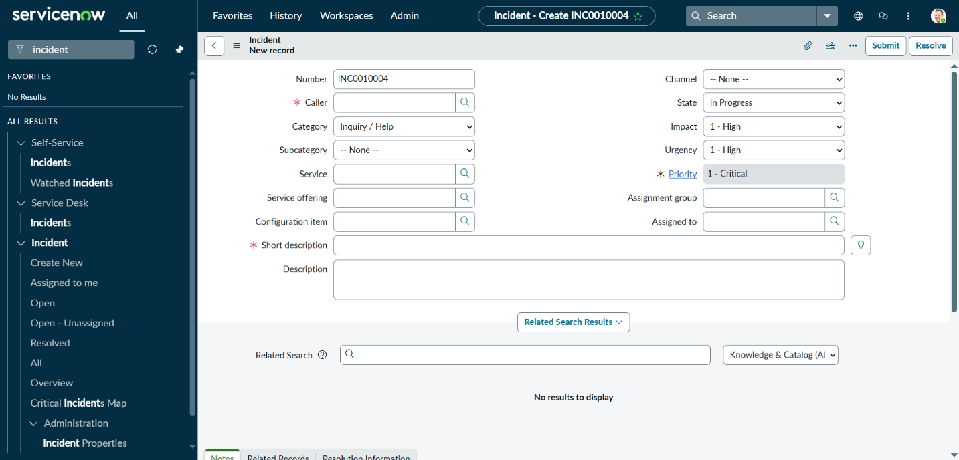
4.The Priority field should now be mandatory.

Conclusion:
This implementation of project successfully demonstrates how UI Policies can be used to enforce business rules dynamically without writing scripts. By making the Priority field mandatory when an incident is moved to In Progress, we ensure data completeness and enhance workflow efficiency. Additionally, using Update Sets.

